

Computer Games Development CW208

SRS and Project Report

Year III

Aaron O’Dea

C00217820

[03-05-2020]

**Faculty of Department of Computing and Networking**

**Open-Book and Remote Assessment Cover Page**

**Student Name: Aaron O’Dea**

**Student Number: C00217820**

**Lecturer Name: Ross Palmer**

**Module: 4th-year project**

**Stage/Year: 4th Year**

**Date: 03-5-20**

**Declaration**

This examination/assessment will be submitted using Turnitin as the online submission tool. By submitting my examination/assessment to Turnitin, I am declaring that this examination/assessment is my own work. I understand that I may be required to orally defend any of my answers, to the lecturer, at a given time after the examination/assessment has been completed, as outlined in the student regulations.

**Contents**

**Acknowledgements** **3**

**Project Abstract** **4**

**Project Introduction** **4**

**Background** **5**

**Project Description** **5**

**Overview** **9**

Philosophy 10

**What is the application supposed to do** **10**

**Who is going to be using this application** **10**

**Context Diagram and Use Cases** **10**

System use Case 11

NPC use case 11

GUI use case 12

**Metrics** **12**

**Design Manual** **14**

**Project Milestones** **16**

**Project Review and Conclusions** **17**

# **Acknowledgements**

I would like to thank the Lecturers of the Games development course for all of the help During this project, especially Ross Palmer. I would also like Przemek Tomczyk for the support on user testing and reviews.

# **Project Abstract**

My project is about researching and testing the possibility of using a Genetic algorithm to produce a population of NPC which reproduces using multiple generations to create a more realistic Pattern of reproduction and development over time.

I am using this Genetic algorithm to target two Npcs from different generations or the same generation once these NPCs have been selected and are of a viable age for reproduction as well as able to reproduce and of opposite genders the npcs will breed and their DNA strings will influence the Child NPC.

Over time these children will all develop towards a preset global goal.

I want to do this because I would like to see the potential ability for a population to be more adaptive to a current environment.

I would also like to one day be able to use this algorithm to create more of a realistic group dynamic within a game instead of a group which have only aesthetic differences but similar backgrounds because they are all derived from one overall best adapted NPC.

With a Group that grows together you should get a similar NPC but distinctive in their own Core statistics and backgrounds. and these core statistics develop through the lifetime of a population. Instead of having a group which simulates a death and just spawns a new NPC,

I want to try to reproduce a child NPC that in theory will have a similar statistic with the parents of the child.

I want to compare what I do with a standard genetic algorithm that is well know.I also want to have different mutations to compare with while using the algorithm to prove that it is not just forcing the statics.In theory the mutation should have some sort of change within the Graph output.

# **Project Introduction**

The project that I have chosen is a look into using a multi object genetic algorithm to produce a population that grows towards a specific goal.

The potential impact of My research project is that the using the algorithm I have created an Npc population will be able to better adapt to circumstance within an area this could be an event that requires a population to better in a certain area such as being stronger or being faster,

This could create a better adaptive population as a whole compared to some other methods.

The reason that I wanted to research this project is because I was interested in genetic algorithms and how they can influence a population and what influences a NPC population within a game and what can be done to improve them for a better game experience.

# **Background**

For my project, I would Like to Research the Possibility of using a genetic algorithm to create an optimal Population of NPCs that are suited to their current environment. It is expected when the NPCs are introduced to a random environment they will over time develop into an optimal state to best survive based on a larger overarching goal of the population.

I want to do this because I would like to see the potential ability for a population to be more adaptive to a current environment.

I would also like to one day be able to use this algorithm to create more of a realistic group dynamic within a game instead of a group which have only aesthetic differences but similar backgrounds because they are all derived from one overall best adapted NPC.

With a Group that grows together you should get a similar NPC but distinctive in their own Core statistics and backgrounds. and these core statistics develop through the lifetime of a population. Instead of having a group which simulates a death and just spawns a new NPC,

I want to try to reproduce a child NPC that in theory will have a similar statistic with the parents of the child.

I want to compare what I do with a standard genetic algorithm that is well know.I also want to have different mutations to compare with while using the algorithm to prove that it is not just forcing the statics.In theory the mutation should have some sort of change within the Graph output.

# **Project Description**

To evaluate the project I am going to use a prescripted set of NPCs with multiple varied status and traits. This prescripted NPC set will be used as a baseline to make a comparison against the NPCs generated by the genetic algorithm.

These NPC in the system will act in the same way and reproduce with the same NPC and will be affected by things with non-varied endpoints and starting points.

Some of the Statistics that the NPCs Have are Speed, Strength, Intelligence and Size. Some of the Traits that are affected by these statistics are the chances a Npc will live past its age cap, How fast the NPC can go this is based on the size and speed, The chance of not taking damage by an event is affected by the intelligence statistic.

For example, if an NPC is born it will live the exact same amount of time as the previous and future NPCs and will act in the same way as previous and future generations. All of the statistics that affect the NPC group as a whole will be standardised and will not vary if the population has a max population size it will not grow past that size. This will give a standardized base of what to compare the genetic algorithm too.

The algorithm that I want to implement is a genetic algorithm which takes a random set of generated NPCs within this group. There will be a set of randomly generated statistics and traits. These statistics will include (health, speed, strength intelligence, age, size), And the traits will include( a preferred trait, a disliked trait, children per cycle, reproductive cooldown).

The NPCs will also pair off for reproduction randomly like I previously stated this approach will anticipate enough of a pool of varied statistic and traits that when reproduction happens and controlled there will be a less likely chance of a plateau in the traits and statistics of a unique NPCs and of the NPC group as a whole leading to a more realistic improvements.

For NPC Reproduction I will also use up to two different Algorithms and Two different Mutations for the algorithm i will use one i design and then One that takes the highest NPC with the statistic that you want. the mutation I will use is a ½ split mutation that is described in the Study section as well as a average mutation which is also describe in the study sections

To give the tests a more realistic real-world scenario I will have timed world events that will target specific NPCs with specific dominant traits. The effect I hope that these events have on the NPC group is that it will give them enough of a realistic variable that will affect the groups NPCs in such a way that it will remove enough NPCs in the group to again stop the genetic algorithm for plateauing. To determine if plateauing is occurring.These events will affect a certain statistic.If the NPC has a high static of this event type it will take a certain amount of damage that is based on how high that statistic is.

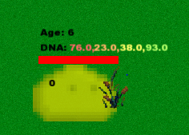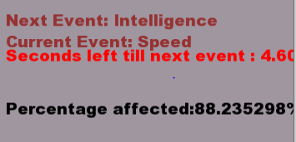

For the visualization of the project I am going to make a sfml window with will represent the NPCs groups area the NPCs will be represented by little NPC images one for male and one for female I will have a standard background the NPCs will also have specific areas that they will go to reproduce the NPCs when in the reproduction will have an empty heart above them once they find a partner they will have full hearts above them they will go to a house where they will reproduce and after reproduction the NPC will have two hearts above the head this will stay as long as they are in there reproduction cool down once they are out of the reproduction cool-down they will return to normal.

during normal events, the NPCs will wander around the map simulating tasks that should be done

NPCs that die during the simulation will go grey and then disappear

The data for all of these tests will be displayed on the sides of the screen the data will be displayed as simple text as well as some minor bar graphs mean age, amount of males amount of females etc

Some of the indicators that the genetic algorithm is improving the experience of the NPC group to be more realistic is that the NPCs will have more specific genetics based on a predetermined goal.

Another indicator is that the NPCs group might die out if the right conditions are met.

For my project, I would Like to research the possibility of using a genetic algorithm to create an optimal Population of NPCs that are suited to their current environment. It is expected when the NPCs are introduced to a random environment they will over time develop into an optimal state to best survive based on a larger overarching goal of the population that is predetermined by the user on the set up of the global variables.

To start the project I want to create a closed environment. Within this environment, I will be able to control all the starting variables of the environment and then after the start of the test, the environment becomes completely independent and continues on its own until it completes its overarching goal or until the tester stops the test due to complacency or a plateau in improvement.

# 

Some of the variables within this environment are the max Distance of breeding NPCs the Mutation rates of all the statistics.What statistic is Wanted, Event timer, Which Algorithm which mutation, Reproduction chance, End Goal

From this enclosed environment I want to be able to monitor the NPC As the reproduce and grow.I will have a sidebar with relevant information such as total males total females total population of all time current population as well as run setting such as mutation rates and what statistics is the NPCs growing towards on this side panel i also want to display a timer that counts down to the next event as well as text which will display what the next event is and what the current event is as well as what percentage of the population has been affected by the current event.

I also want to indicate the affected NPC in the Environment. I will do this by highlighting them with a circle.

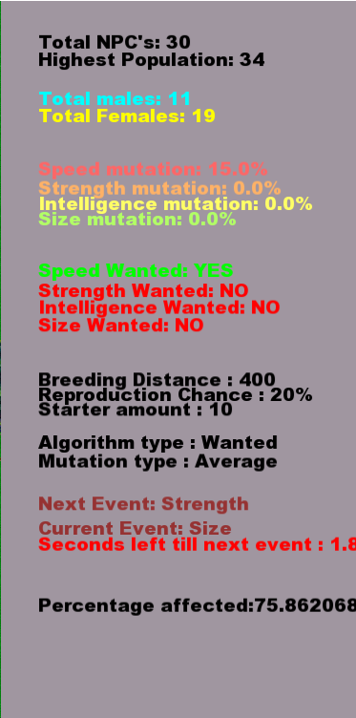

With the environment setup and relevant data being displayed on the side panel underneath I also want to track statistics of the NPCs. to do this I am going to make a graph which the user can switch between With the left and right arrow keys. This graph will track the current selected average statistic.This graph will update with every change in the population.

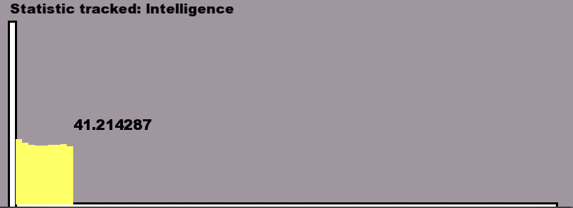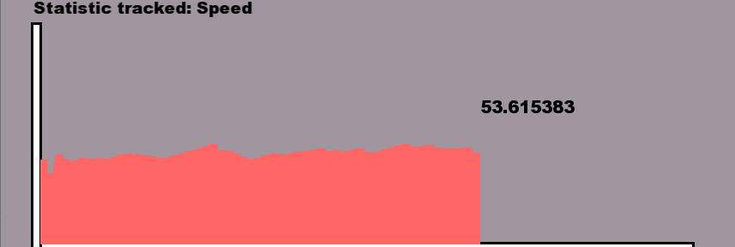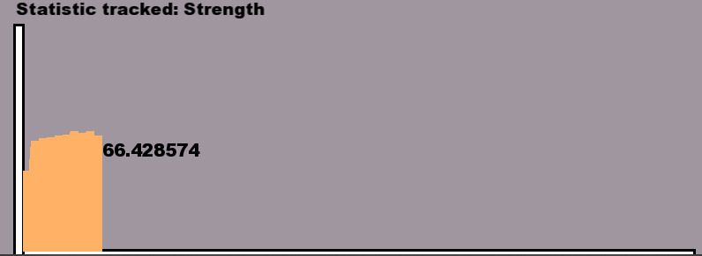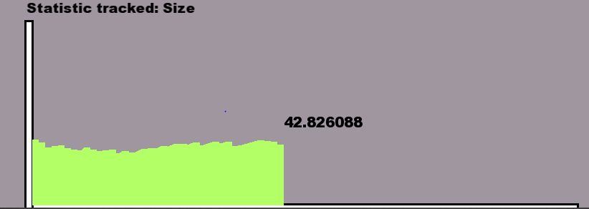

With all this tracking of data I also want to keep a log of it in the background of the run I will log all of the Data for each statistic and the current total population at the end of a run it will output all of their data to a text file as well as a settings file which holds all of the current setting of the Run.

Because I will have to perform multiple runs of the system to gather data I will include a way to reset the current run and start a new run with the same setting.





with the outline description above I will also have to have a main menu which will allow a user to choose all of the

Global statistics that have been previously described include Mutation Rates age caps ,which statistic is wanted as well as other variables which affect the NPCs while they are in their environment.

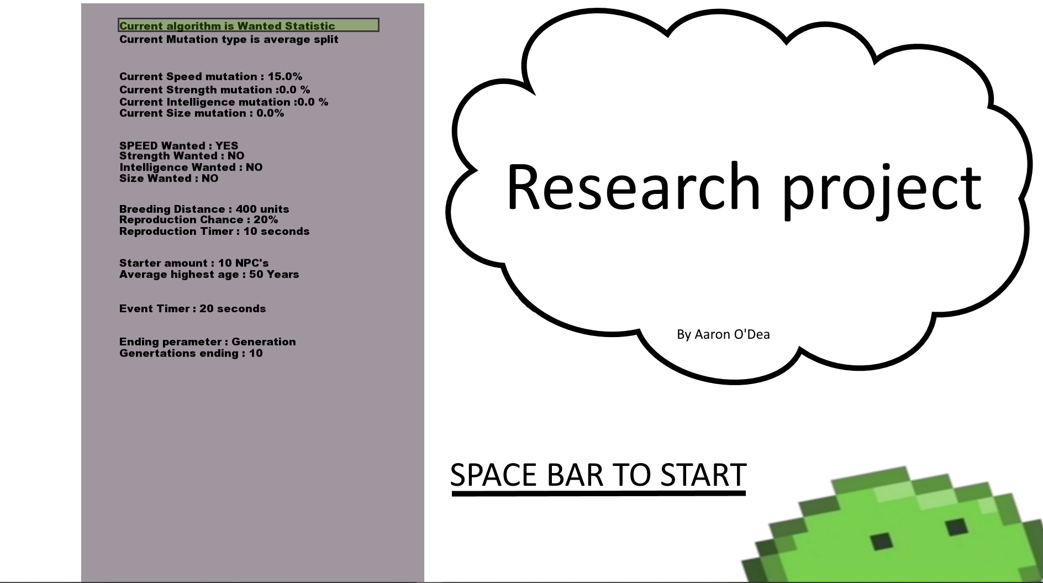

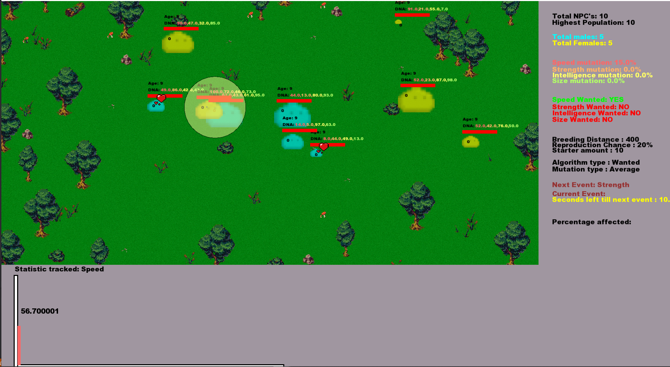

From the above statement slight alterations to the systems might have occurred such changes like traits which were removed and replaced with a better Statistic system for the NPCs.

From the project I learned alot about genetic algorithms and differences in genetic algorithms as well as what different mutations and how certain external variables can be used to alter them.

Some of the technical achievements that I have made is greateing my genetic algorithm that takes more into account than the best NPC but instead takes a more realistic adaptive approach. My algorithm also improves a group rather than each individual NPC which is then copied to make a group.

# **Overview**

## ***Philosophy***

The ability for a group of NPCs to maintain a more dynamic realistic experience

**Define the Application**

For my project, I would Like to Research the Possibility of using a genetic algorithm to create an optimal Population of NPCs that are suited to their current environment. It is expected when the NPCs are introduced to a random environment they will over time develop into an optimal state to best survive based on a larger overarching goal of the population.

# **What is the application supposed to do**

The application is meant to be used to try to show a realistic way of developing a group of NPCs and giving them the ability to dynamically adapt to events. The application is also used this algorithm against another genetic algorithm along with Mutation that affect the Statistics in each reproduction cycle of a NPC.

# **Who is going to be using this application**

A person with an interest in different genetic algorithms or a person that wants to see how variables influence a genetic algorithm.

# **Context Diagram and Use Cases**

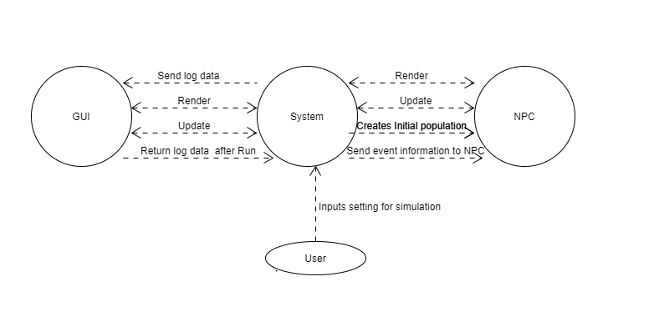

### **System use Case**

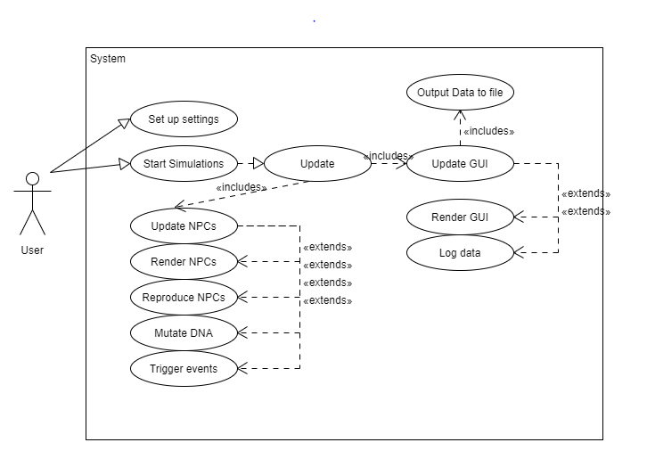

### **NPC use case**

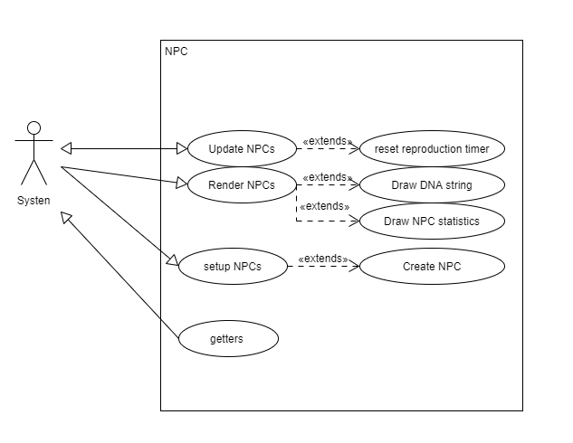

### **GUI use case**

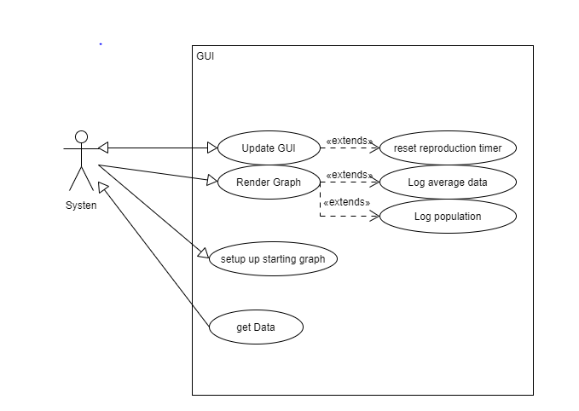

# **Metrics**

To gather my data I will use files that are output by the system after each run theses files contain a log of all of the average Statistics eg average Speed, Average Size etc as well as the Total running population. With this data and a setting file which is the current Setting of the run.

I will input all of the data into a spreadsheet and from this spreadsheet condense it into a graph.

For my comparison I will compare two algorithms and two Mutations .This gives me a total of four variations in total. I will before Nine runs for each variation.

Once all of the data is gathered I will then compare the most Average Group removing outliers from each Combination and compare them.

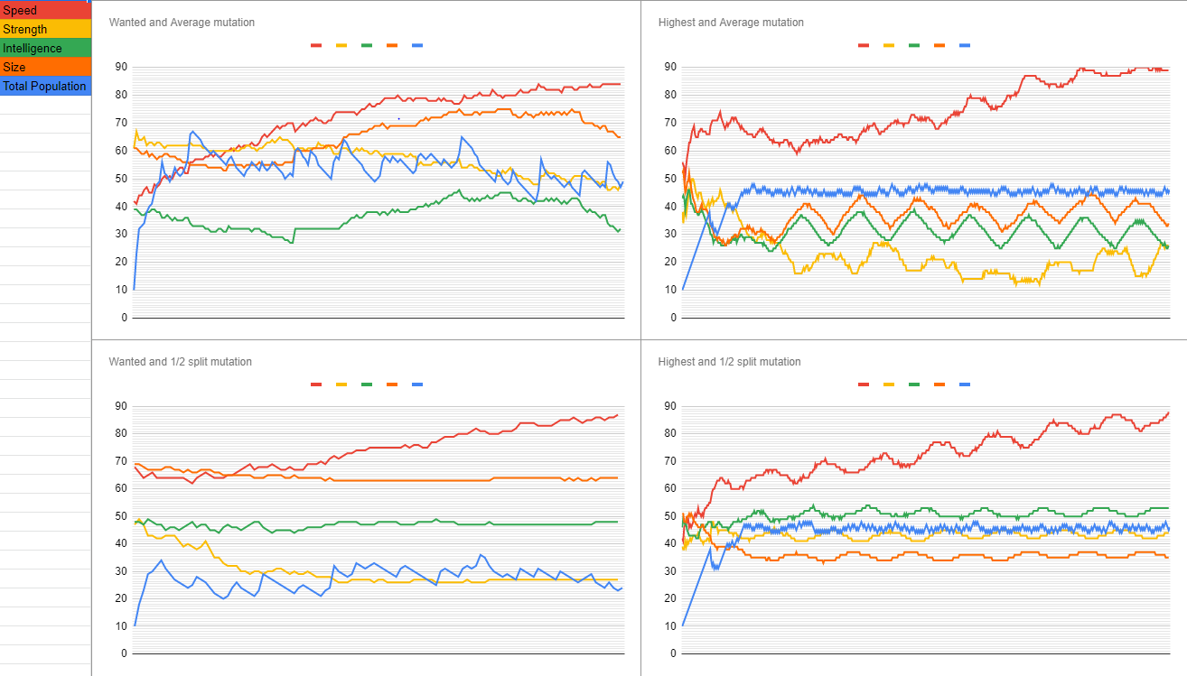

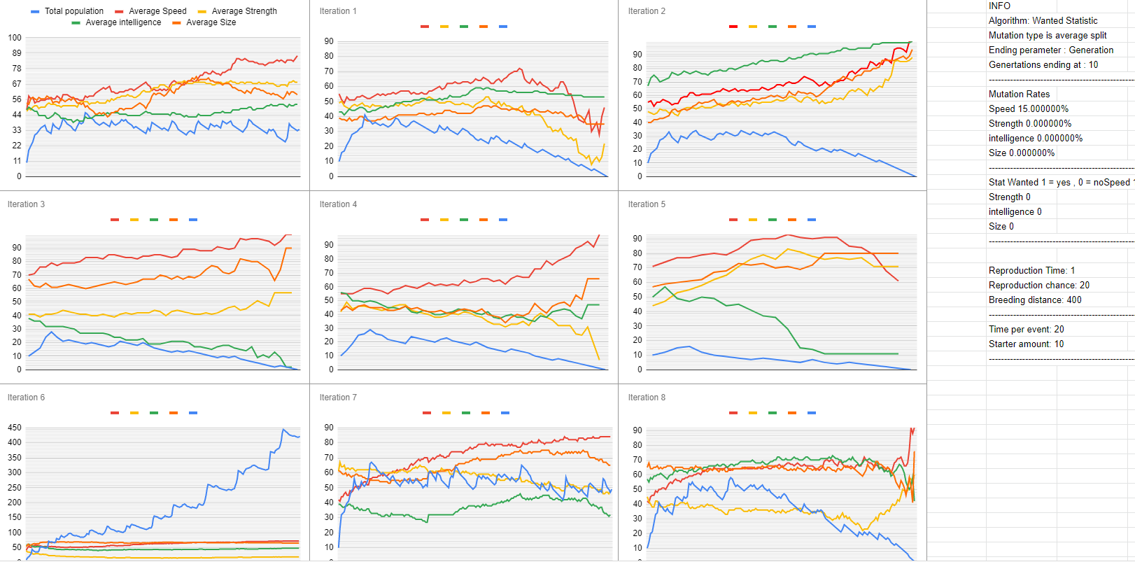

**Is there a precedent for this application? (Your inspiration):**

I want to do this because I would like to see the potential ability for a population to be more adaptive to a current environment.

I would also like to one day be able to use this algorithm to create more of a realistic group dynamic within a game instead of a group which have only aesthetic differences but similar backgrounds because they are all derived from one overall best adapted NPC.

With a Group that grows together you should get a similar NPC but distinctive in their own Core statistics and backgrounds. and these core statistics develop through the lifetime of a population. Instead of having a group which simulates a death and just spawns a new NPC,

I want to try to reproduce a child NPC that in theory will have a similar statistic with the parents of the child.

# **Design Manual**

When the program beings a main menu screen will appear on this screen will be all of the settings that will be applied to that run of the algorithm this includes but is not limited to

What type of algorithm, what type of Mutation is being used, what is the mutation rate of Speed, Strength intelligence, Size , What statistics are wanted for that run, age restriction event timers, breeding distance, End condition and reproduction chance. All of these options will be changeable the user will move the selector which will highlight the current selected option with a box up or down using the up and down arrow keys to select the specific value for the currently selected option they will increase or decrease this value by using the left and right arrow keys.

Once the user has selected all of the settings they want for the run they will start the simulation by pressing the spacebar.

Once the space bar is pressed the simulation will begin.

Underneath the main viewing environment will be a graph this graph tracks one of the statistics o f the npc population. currently tracked statistics can be changed by using the left and right arrow keys.

To access the Logs of the previous run the user goes to the ASSets folder and opens the files folder within,

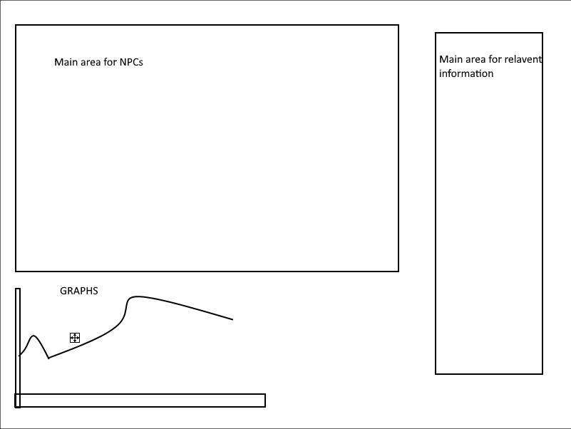

In an overview of application the system is the center piece which connects to the gui and the gui connects back to the system the system also connects to the NPC class which connects back to the system.

# **Project Milestones**

If anything is not completed within the milestone the task is then assigned to the next milestone list.

**Milestone 1 (End of October 2019)**

For the first milestone of the project I wanted to get a basic structure of the project operational, this includes the initial game loop of the project which allows me to render updates and take keyboard inputs from the user.

I also want to create a basic NPC with a genome. This genome includes 4 sets of DNA that are specific values. These NPCs should have a texture and be able to wander around a specific area.

**Milestone 2 (End of December 2019)**

For the second milestone, I wanted to include my algorithm and a mutation which allows the NPC to reproduce based on variables such as age, distance, reproduction cycle, gender and wanted statistic this wanted statistic would become the base for my fitness assessment based on the strength of the state and how many wanted stats the current NPC has the chance of reproduction increase. I also want a basic mutation which takes each Genome sequence from each parent NPC and produces a new genome and adds a mutation to it which affects the child NPC.

**Milestone 3 (End of February 2020)**

For my third milestone, I would like to implement a graph which tracks the average statistic of the population. This graph should increase and decrease with each change in population. The graph should be able to switch between each statistic with a keyboard input as well as log the data in a background file for future use.

The highest NPC of the currently Tracked statistic should be highlighted on the screen by an indicator.

I also want to show specific statistics on the side panel of the screen E.g Total population female, male split and the highest reached population within the current run.

I also want to set up a basic menu with the ability to determine some statistics within the system such as age cap and reproduction time.

**Milestone 4 (End of March 2020)**

For my fourth milestone, I want to introduce a second mutation and a second algorithm. This will be my comparison for my algorithm.

I also want to add in events to the game that happen at set intervals to the NPCs. These events will affect the NPCs with high statistics of that event type (speed events target NPC’s with a high statistic in speed). I also want to show the percentage of the NPCs affected on the side panel as well as what is the current event and what is the next event. I also want to highlight each NPC that was affected by the current event.

I want to add more data to the main menu which the user can choose such as mutation rate, what statistic is wanted and other data that might affect the run.

I want to display the important information for the run on the side panel of the game screen that includes mutation rates, statistics, wanted what type of algorithm and what type of mutation is being used.

**Final Milestone (29th of April 2020)**

For my final milestone, I want to output the collected data and have a way of restarting the Current run with the same settings.

During this milestone, I also want to address any problems that I have found such as overpopulation render lag. Population caping.

I also want to go back over the code and clean up anything that could be improved and reduce code size where appropriate as well as comment on anything that was missed.

I also want to add anything that might make the Simulation look better colours to indicate statistics and so on.

The final thing I want to do is run Doxygen on the code to produce a file which should make my code easier to understand.

# **Project Review and Conclusions**

In conclusion from the data that I have gathered I show a quicker Growth using either of the two different types of genetic algorithm mutation types.

My Algorithm which takes multiple different variables into account when picking another NPC’s to reproduce with.

This growth is specified to a certain statistic of an NPC’s which is predetermined in settings

I determined that for a long term steady growth most optimal and a ½ split mutation is best suited.

While a quick growth in a short amount of time the most Appropriate and average mutat

ion

The problems that occurred were how to determine what has improved and based on what statistics.

How to measure conclusions of runs in reference to other run and population explosions skewing the data as well as population dying too soon.

I would advise someone else who wants to do a similar problem to create a better environment for the npcs and an environment which influences the NPCs in a better way. I would also advise the person to look into how to control a larger population of NPCs in a way to not lag the system.

if I was starting again i would do what i stated above as well as coming up with more variables which could affect the population

I feel that the technologies used were sufficient in displaying and outputting data in the future i would want to use XML for this so i could also maybe input data into the system

if a future student wants to undertake a project similar to this they might also want to see if they could introduce a neural network that would take the data from the previous run and change variables to try to find a most optimal set of settings for a certain high level goal.